Wumpus World Variant Lava Cells and the Heat Percept
Student’s Name: Chisom Ashley Obi
COA207 – Foundations of Artificial Intelligence
Date: 18th May 2026

Table of Contents
1. Problem Analysis 3
Goals and Constraints 3
Environment Description 3
The Twist: Lava Cells and the Heat Percept 4
2. Justification of Approach 4
3. System Representation 5
4. Algorithmic Plan 5
1. Reflection on My System 7
Strengths 7
Limitations 7
2. Advanced AI Contrast: Deep Reinforcement Learning 8
Capabilities 8
Transparency and explainability 8
Unintended consequences 9
3. Ethical Reflection and Trade-offs 9
Transparency and Explainability 9
Accountability for Mistakes 9
Bias and Fairness 10
Control and Predictability 10
Trust and Over-reliance 10
Does Greater Capability Mean Better Ethics? 11

Problem Analysis and AI System Design

1. Problem Analysis

Goals and Constraints
The agent's task is to traverse a 5x5 partially observable grid to retrieve the gold and make it back to the starting point (1,1) without getting trapped. There are three hazards to die on entry: Pits, the Wumpus and the new hazard Lava cells. The agent starts with only one arrow and no information on the location of hazards. Additionally, hazard placement is fixed at the beginning of each episode, the agent can move only in four cardinal directions, the agent can only see the cell he is in, and hazard cells cannot be accessed diagonally or through the grid's boundary.

Environment Description
Property | Value
Observable | Partial — agent perceives current cell only
Deterministic | Yes — all actions produce fixed outcomes
Sequential | Yes — earlier decisions affect future states
Static | Yes — layout is fixed; Wumpus death is the only state change
Discrete | Yes — finite set of cells and actions
Single-agent | Yes
The agent may receive up to six percepts at each cell:
Percept | Meaning
Stench | Wumpus is in an orthogonally adjacent cell
Breeze | A Pit is adjacent
Heat (new) | A Lava cell is adjacent
Glitter | Gold is in the current cell
Bump | Agent attempted to move into a wall
Scream | Wumpus has been killed

The Twist: Lava Cells and the Heat Percept
Lava is contained in one or more of the cells and is lethal on contact. Lava is unique among Pits (signaled by Breeze) and the Wumpus (signaled by Stench) in that it produces a different percept (Heat) in each orthogonally adjacent cell. This necessitates that for each type of hazard the agent has to keep three separate inference chains in parallel, one for each type of hazard, while keeping the knowledge base tractable for propositional logic, and its complexity high. The agent needs to avoid mixing the signals of both Lava and Pits, as both are completely independent of each other, and the reasoning problem is also interesting because of that.

2. Justification of Approach
A propositional logic inference agent is the most appropriate choice. The environment is a deterministic, discrete and each percept contains provably correct information. The rules like "If no Heat is detected at a visited cell, then unvisited neighboring cells have no Lava" can be guaranteed. Each of the decisions is fully traceable to symbolic rules to satisfy the assessment's explainability requirement.
A reactive agent (for example, random walk) is not appropriate because it does not have the ability to store knowledge over time. It would keep on threatening cells already determined to be hazardous and would not be able to take advantage of safe inferences that the logic agent makes.
A model-free reinforcement learning agent also does not work: it needs many episodes to converge, cannot guarantee safety in one episode, and leaves no “reasoning chain” of explainable reasoning steps that is vital to the value of this domain.
3. System Representation
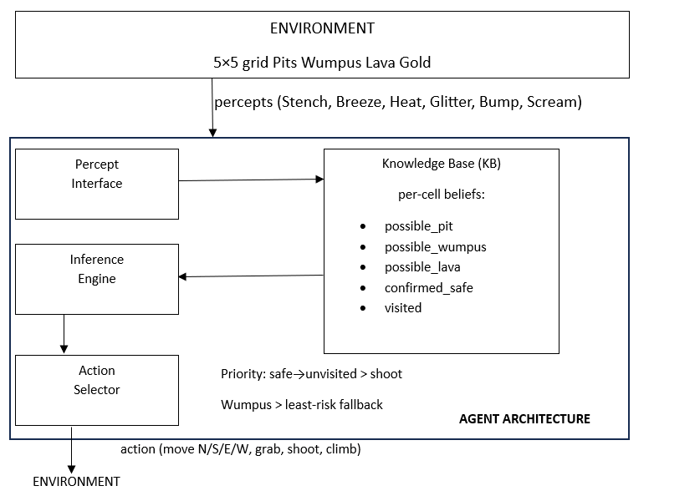
Figure 1: Agent architecture for the Lava Wumpus World variant.

4. Algorithmic Plan
INITIALISE:
KB ← empty knowledge base (all cells: unknown)
safe_cells ← {(1,1)}
visited ← {}
has_gold ← False
has_arrow ← True

EACH STEP:
percepts ← sense(current_cell)
add current_cell to visited
UPDATE_KB(current_cell, percepts)
INFER_SAFE_CELLS()

IF Glitter IN percepts:
grab_gold()
has_gold ← True

IF has_gold AND current_cell = (1,1):
climb_out()
STOP

IF unvisited safe cells exist:
move_to(nearest unvisited safe cell via BFS)
ELSE IF wumpus_cell confirmed AND has_arrow:
shoot_arrow(direction of wumpus_cell)
has_arrow ← False
ELSE:
move_to(unvisited cell with lowest combined hazard probability)

UPDATE_KB(cell, percepts):
FOR each orthogonal neighbour N of cell:
IF Stench NOT in percepts: KB.no_wumpus(N) ← True
IF Breeze NOT in percepts: KB.no_pit(N) ← True
IF Heat NOT in percepts: KB.no_lava(N) ← True
IF Stench in percepts: KB.poss_wumpus(N) ← True
IF Breeze in percepts: KB.poss_pit(N) ← True
IF Heat in percepts: KB.poss_lava(N) ← True

INFER_SAFE_CELLS():
FOR each unvisited cell C:
IF KB.no_pit(C) AND KB.no_wumpus(C) AND KB.no_lava(C):
add C to safe_cells
Negative percepts are the most powerful signal: a single percept-free visit to a cell rules out hazards in all its neighbors simultaneously, consistent with standard propositional Wumpus logic (Russell and Norvig, 2021).

Evaluation, Reflection, and Ethical Analysis

1. Reflection on My System
The implemented agent derives conclusions from propositional logic about a 5x5 grid with three independent types of hazards: Pits, Wumpus and Lava cells. Each step, the agent modifies a symbolic knowledge base based on percepts and then performs an action based upon the rules of inference. The system is determinate, that is, the decisions made will be the same if the same sequence of percepts is presented on the same grid.

Strengths
The agent's reasoning is fully transparent. Each action is explained by a clearly-stated rule, such as "Heat was not present at (4,0) and (4,1), so there was no lava at (3,0) and (3,1). This allows errors to be quickly identified and rectified. What's more, the system cannot react in a way not expected by its designer: the system doesn't have the ability to find unexpected patterns or act beyond what the rules specify.

Limitations
The agent's inference is fragile, in ambiguous contexts. If more than one unvisited cell is able to account for the same percept, the system is not able to reason about which one is more likely to be dangerous; it simply defaults to a “lowest hazard score” heuristic. The system is also incapable of learning: If a new type of percept was added, the rules would have to be rewritten. Finally, the 5x5 grid with 3 hardcoded hazard types is a trivialization of any actual navigation situation, and therefore, it is not easy to extrapolate the results of the 5x5 grid to other situations.

2. Advanced AI Contrast: Deep Reinforcement Learning
A more modern approach would be to train a deep reinforcement learning (DRL) agent using thousands of episodes of the Wumpus World, such as a Deep Q-Network (DQN) or Proximal Policy Optimization (PPO). Instead of explicitly programming rules, this approach would learn a policy that associates observations with actions by trial and error with the help of a reward signal (for example, +1000 if a gold coin is picked up, -1000 if the player dies, -1 if the player takes a step).
Capabilities
A DRL agent will be able to generalize without the need to manually update rules for different grid sizes and configurations. It might find novel solutions, like the temporal pattern of Heat percepts over several cells and triangulate the location of lava, which the designer might not have thought of. It would also scale naturally: if a fourth hazard type is added, only the reward function needs to be updated and the machine retrained, but not the design of all the inference rules.

Transparency and explainability
The contrast is stark here. A neural network is not human-readable and its weights are defined by a DRL agent's policy. There is no simple logical answer to the question "why did the agent move left and not right?". Partial explanations can be generated using post-hoc explanation methods (for example, saliency maps, LIME), but these are only approximations of the network's actual reasoning, not the actual reasoning.

Unintended consequences
Also, known as reward hacking, DRL agents exploit reward functions which designers didn't foresee. You might find that an agent could get the best rewards out of the game by not going for the gold at all, because they will receive a penalty if they die. It may turn out that the agent could get the maximum possible reward from the game by never going for the gold because if they die, they get a penalty.

3. Ethical Reflection and Trade-offs

Transparency and Explainability
My rule-based system is designed to be fully explicable. This is important, not just in terms of assignments but also as a general rule: If an AI agent makes decisions that have consequences (for example, navigation, advice, diagnosis), then their ability to explain the reasons for the decision facilitates human oversight and trust. This is given up entirely by the DRL alternative. AI systems are increasingly being applied in more critical contexts, such as medical diagnosis, autonomous driving and judicial risk assessment, and the opacity of neural networks is no longer just a technical issue, but an ethical one. If an agent can't answer why it took a certain course, they can't be held accountable for it.

Accountability for Mistakes
In my system, if the player makes a mistake (let's say they go into an ambiguous cell, which turns out to be deadly), they will be able to refer back to a particular missing inference rule, or an unlucky placement of cells in the grid. The responsibility lies with the rule’s designer. A DRL system has diffuse sources of error, data, reward function, architecture, and emergent behavior, none of which is directly responsible for the source of error. This helps spread the responsibility and can make it possible to shift the blame forever.

Bias and Fairness
Unlike data-driven agents, Propositional Logic agents don't have a training set and thus no data-based bias. All rules are applied to every cell, no matter where it is located. If a DRL agent is trained on a certain distribution of grid configurations, then it might be prone to systematically misbehaving (Mnih et al. 2015), that is, a grid that has a lava cell in a certain position will be more likely to have a lava cell in the same position when tested. This is a minor point in the Wumpus domain, but is a major point when extrapolating to real-world navigation or decision making.

Control and Predictability
My agent is deterministic and its behavior is completely predictable based on its rules. A DRL agent, good on average, can be bad at the extremes of its training distribution. The differences between episodes; strategies they find, the failure modes that occur; are unpredictable. This unpredictability is an ethical issue, not just a technical constraint, in a domain in which predictability is essential for safety (industrial robotics, medical assistance).

Trust and Over-reliance
My system is very easy to use and because of its simple design and its known shortcomings, the user is not likely to take it beyond its capabilities. There is little risk of over-reliance. A DRL system that does a good job on a lot of test cases can give a false sense of robustness (Ribeiro et al. 2016). Users, including those creating software, can rely on it to exceed its limits of reliability, and suffer harm as a result.

Does Greater Capability Mean Better Ethics?
As the comparison above indicates, technical strength is not directly correlated with ethical results. The DRL system is capable of addressing more complicated problems, of generalizing more broadly and of needing less manual design, but by doing so, it becomes less explainable, less accountable, and less predictable. These do not need to be designed out of a learning paradigm; they are properties of a learning paradigm. Essentially, the ethical AI system needs to be able to perform its job well, while also being transparent, and ensuring that accountability and control are achievable even as its performance improves. Even though this is a partial, and flawed, model of what AI reasoning could be like, it helps to provide a benchmark, one that can be evaluated against more powerful models.

References
Mnih, V. et al. (2015). Human-level control through deep reinforcement learning. Nature, 518, 529–533.
Russell, S. and Norvig, P. (2021). Artificial Intelligence: A Modern Approach (4th ed.). Pearson.
Ribeiro, M. T., Singh, S. and Guestrin, C. (2016). "Why should I trust you?": Explaining the predictions of any classifier. KDD 2016.

Repository link : https://github.com/Obi123-del/coa207-wumpus-world

